- For the portions of circuit given below, the circuits represents LPC2129 uC connected to

- AL_SW & AL_LED
- AL_SW &AH_LED
- AH_SW & AL_LED
- AH_SW &AH_LED
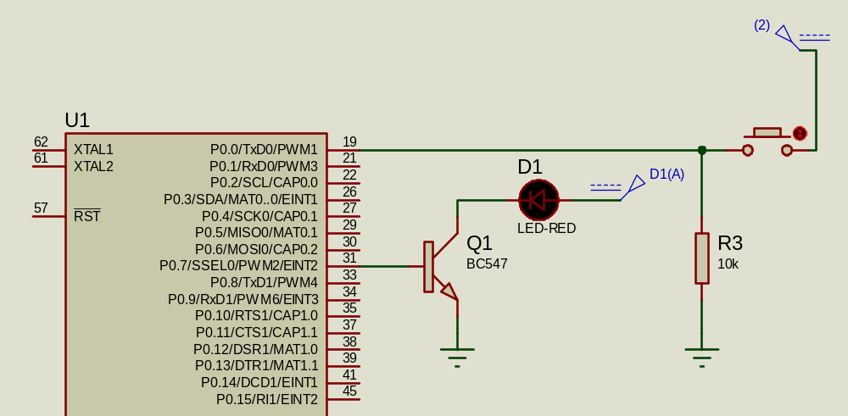

- For the portions of circuit given below, the circuits represents LPC2129 uC connected to

- AL_SW & AL_LED
- AL_SW &AH_LED
- AH_SW & AL_LED
- AH_SW &AH_LED
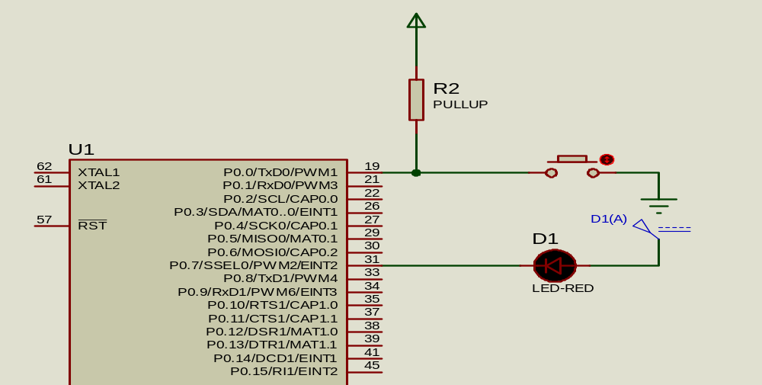

- For the portions of circuit given below, the circuits represents LPC2129 uC connected to

- AL_SW & AL_LED
- AL_SW &AH_LED
- AH_SW & AL_LED
- AH_SW &AH_LED

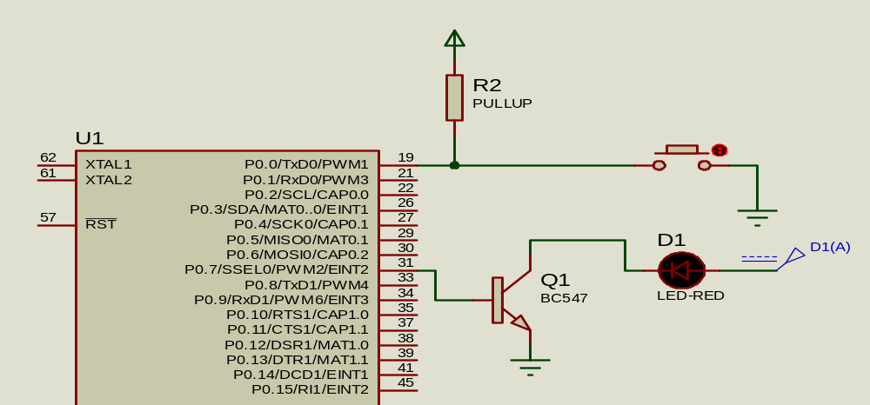

- For the portions of circuit given below, the circuits represents LPC2129 uC connected to

- AL_SW & AL_LED
- AL_SW &AH_LED
- AH_SW & AL_LED
- AH_SW &AH_LED

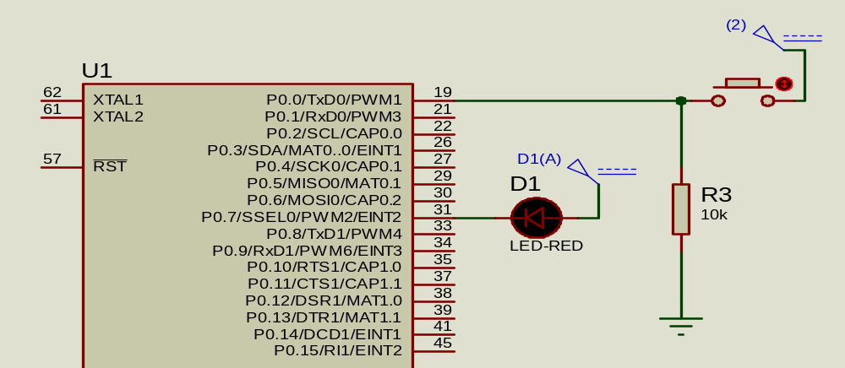

- For the portion of the circuit given below,showing LPC2129 uC ,Switch @p0.0 & LED @p0.7. Which among the below given codes would be correct to reflect the status of the switch as pressed/released by operating the LED to be ON/OFF respectively.

^{a)}  ^{#include <lpc21xx.h>}  ^{#define SW 0}  ^{#define LED 7}  ^{int main()}  {  ^{IODIR0 |= 1<<LED;}  ^{while(1)}  {  ^{if(((IOPIN0>>SW)&1)==0)}  ^{IOCLR0=1<<LED; //led on}  ^{else}  ^{IOSET0=1<<LED; //led off}  }  } | ^{b)}  ^{#include <lpc21xx.h>}  ^{#define SW 0}  ^{#define LED 7}  ^{int main()}  {  ^{IODIR0 |= 1<<LED;}  ^{while(1)}  {  ^{if(((IOPIN0>>SW)&1)==0)}  ^{IOSET0=1<<LED; //led on}  ^{else}  ^{IOCLR0=1<<LED; //led off}  }  }
^{c)}  ^{#include <lpc21xx.h>}  ^{#define SW 0}  ^{#define LED 7}  ^{int main()}  {  ^{IODIR0 |= 1<<LED;}  ^{while(1)}  {  ^{if(((IOPIN0>>SW)&1)==1)}  ^{IOCLR0=1<<LED; //led on}  ^{else}  ^{IOSET0=1<<LED; //led off}  }  } | ^{d)}  ^{#include <lpc21xx.h>}  ^{#define SW 0}  ^{#define LED 7}  ^{int main()}  {  ^{IODIR0 |= 1<<LED;}  ^{while(1)}  {  ^{if(((IOPIN0>>SW)&1)==1)}  ^{IOSET0=1<<LED; //led on}  ^{else}  ^{IOCLR0=1<<LED; //led off}  }  }

- For the portion of the circuit given below,showing LPC2129 uC ,Switch @p0.0 & LED @p0.7. Which among the below given codes would be correct to reflect the status of the switch as pressed/released by operating the LED to be ON/OFF respectively.

^{a)}  ^{#include <lpc21xx.h>}  ^{#define SW 0}  ^{#define LED 7}  ^{int main()}  {  ^{IODIR0 |= 1<<LED;}  ^{while(1)}  {  ^{if( ! ((IOPIN0>>SW)&1) )}  ^{IOCLR0=1<<LED; //led on}  ^{else}  ^{IOSET0=1<<LED; //led off}  }  } | ^{b)}  ^{#include <lpc21xx.h>}  ^{#define SW 0}  ^{#define LED 7}  ^{int main()}  {  ^{IODIR0 |= 1<<LED;}  ^{while(1)}  {  ^{if( ! ((IOPIN0>>SW)&1) )}  ^{IOPIN0 &= ~(1<<LED); //led on}  ^{else}  ^{IOPIN0 |= 1<<LED; //led off}  }  }
^{c)}  ^{#include <lpc21xx.h>}  ^{#define SW 0}  ^{#define LED 7}  ^{int main()}  {  ^{IODIR0 |= 1<<LED;}  ^{while(1)}  {  ^{if(((IOPIN0>>SW)&1)==0)}  ^{IOCLR0=1<<LED; //led on}  ^{else}  ^{IOSET0=1<<LED; //led off}  }  } | ^{d)}  ^{#include <lpc21xx.h>}  ^{#define SW 0}  ^{#define LED 7}  ^{int main()}  {  ^{IODIR0 |= 1<<LED;}  ^{while(1)}  {  ^{if(((IOPIN0>>SW)&1)==0)}  ^{IOSET0=1<<LED; //led on}  ^{else}  ^{IOCLR0=1<<LED; //led off}  }  }

- For the portion of the circuit given below,showing LPC2129 uC ,Switch @p0.0 & LED @p0.7. Which among the below given codes would be correct to reflect the status of the switch as pressed/released by operating the LED to be ON/OFF respectively.
^{a)}
^{#include <lpc21xx.h>}
^{#define SW 0}
^{#define LED 7}
^{int main()}
{
^{IODIR0 |= 1<<LED;}
while(1) { ( ! ((IOPIN0>>SW)&1) ) ? (IOPIN0&=~(1<<LED)) : (IOPIN0|=1<<LED) ; }
}
^{b)}
^{#include <lpc21xx.h>}
^{#define SW 0}
^{#define LED 7}
^{int main()}
{
^{IODIR0 |= 1<<LED;}
while(1) { ( ! ((IOPIN0>>SW)&1) ) ? (IOPIN0|=(1<<LED)) : ( IOPIN0&=~(1<<LED) ) ; }
}
^{c)}
^{#include <lpc21xx.h>}
^{#define SW 0}
^{#define LED 7}
^{int main()}
{
^{IODIR0 |= 1<<LED;}
while(1) { IOPIN0= ((IOPIN0&~(1<<LED)) | (((IOPIN0>>SW)&1)<<LED)); }
}
^{c)}
^{#include <lpc21xx.h>}
^{#define SW 0}
^{#define LED 7}
^{int main()}
{
^{IODIR0 |= 1<<LED;}
while(1) { IOSET0= ((IOSET0&~(1<<LED)) | (((IOSET0>>SW)&1)<<LED)); }
}

- For the portion of the circuit given below,showing LPC2129 uC ,Switch @p0.0 & LED @p0.7. Which among the below given codes would be correct to reflect the status of the switch as pressed/released by operating the LED to be ON/OFF respectively.

^{a)}
^{#include <lpc21xx.h>}
^{#include “types.h”}
^{#include “defines.h”}
^{#define SW 0}
^{#define LED 7}
^{int main()}
{
^{SETBIT(IODIR0,LED);}
while(1) { ! READBIT(IOPIN0,SW) ? CLRBIT(IOPIN0,LED) : SETBIT(IOPIN0,LED) ; }
}
^{b)}
^{#include <lpc21xx.h>}
^{#include “types.h”}
^{#include “defines.h”}
^{#define SW 0}
^{#define LED 7}
^{int main()}
{
^{SETBIT(IODIR0,LED);}
while(1) { ! READBIT(IOPIN0,SW) ? SCLRBIT(IOCLR0,LED) : SSETBIT(IOSET0,LED) ; }
}
^{c)}
^{#include <lpc21xx.h>}
^{#include “types.h”}
^{#include “defines.h”}
^{#define SW 0}
^{#define LED 7}
^{int main()}
{
^{SETBIT(IODIR0,LED);}
while(1) { ! READBIT(IOPIN0,SW) ? SETBIT(IOCLR0,LED) : SETBIT(IOSET0,LED) ; }
}
^{d)}
^{#include <lpc21xx.h>}
^{#include “types.h”}
^{#include “defines.h”}
^{#define SW 0}
^{#define LED 7}
^{int main()}
{
^{SETBIT(IODIR0,LED);}
while(1) { WRITEBIT(IOPIN0,LED,READBIT(IOPIN0,SW)) ; }
}
^{e)}
^{#include <lpc21xx.h>}
^{#include “types.h”}
^{#include “defines.h”}
^{#define SW 0}
^{#define LED 7}
^{int main()}
{
^{SETBIT(IODIR0,LED);}
while(1) { READWRITEBIT(IOPIN0,LED,SW) ; }
}
^{f)}
^{#include <lpc21xx.h>}
^{#include “types.h”}
^{#include “defines.h”}
^{#define SW 0}
^{#define LED 7}
^{int main()}
{
^{SETBIT(IODIR0,LED);}
while(1) { ! READBIT(IOPIN0,SW) ? SCLRBIT(IOCLR0,LED) : SSETBIT(IOSET0,LED) ; }
}
^{g)}
^{#include <lpc21xx.h>}
^{#include “types.h”}
^{#include “defines.h”}
^{#define SW 0}
^{#define LED 7}
^{int main()}
{
^{SETBIT(IODIR0,LED);}
while(1) { READWRITEBIT2(IOPIN0,LED,IOPIN0,SW) ; }
}

